

NAME:

MUHAMMAD MUDASSIR RAZA CLASS:

BSCS (3-A) SUBJECT:

DATABASE MANAGEMENT SYSTEM

TEACHER:

MISS SANA QABIL

1. List the customer number, the name, the phone number, and the city of customers.

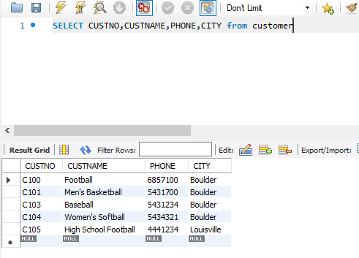

2. List the customer number, the name, the phone number, and the city of customers who reside in Colorado (State is CO).

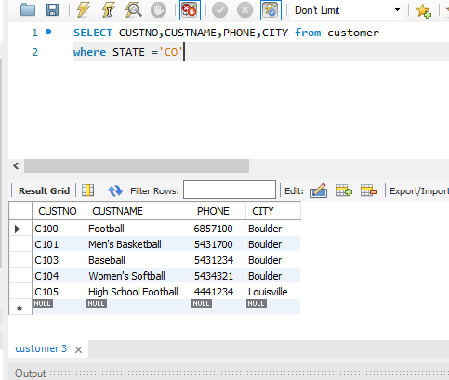

3. List all columns of the *EventRequest* table for events costing more than $4000. Order the result by the event date (*DateHeld*).

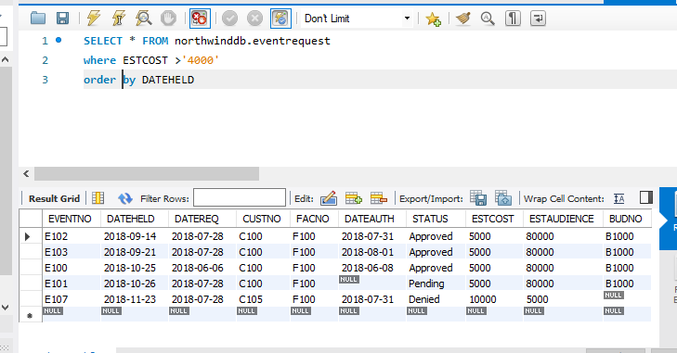

4. List the event number, the event date (DateHeld), and the estimated audience number with approved status and audience greater than 9000 or with pending status and audience greater than 7000.

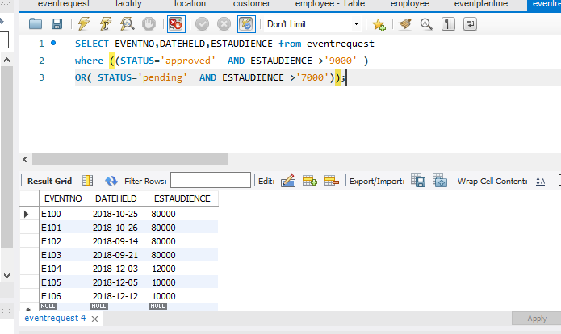

5. List the event number, event date (DateHeld), customer number and customer name of events placed in January 2018 by customers from Boulder.

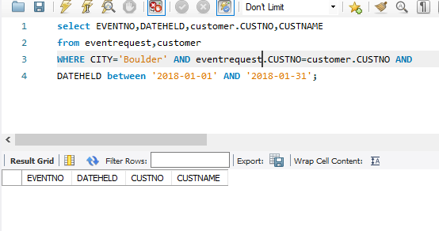

6. List the average number of resources used (NumberFld) by plan number. Include only location number L100.

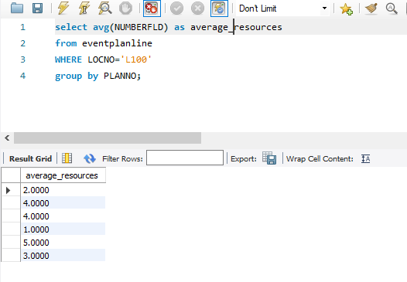

7. List the average number of resources used (NumberFld) by plan number. Only include location number L100. Eliminate plans with less than two event lines containing location number L100.

